Part Number: PU060-52015-P1

Kit Contents
Item # | Quantity Reqd. | Description
1 | 1 | Rear Passenger Side Mudguard
2 | 1 | Rear Driver Side Mudguard
3 | 1 | Hardware Kit
4 | 1 | Instruction Sheet (Electronic Copy)
Hardware Bag Contents
Item # | Quantity Reqd. | Description
1 | 2 | 19mm Screws
2 | 2 | Spring Clips
3 | 4 | Push Pins
Additional Items Required For Installation
Item # | Quantity Reqd. | Description
1
2
3
Conflicts
Recommended Tools
Personal & Vehicle Protection | Notes
None
Special Tools | Notes
None
Installation Tools | Notes
Screwdriver | Phillips # 2 & Slot
Drill
Drill Bit | 6m (1/4”) & 8mm (5/16”)
Clean Cloth/Rag
Special Chemicals | Notes
Cleaner | VDC Approved Cleaner or Soap & Water Mixture
General Applicability
All models
Recommended Sequence of Application
Item # | Accessory
1
2
3
*Mandatory
Vehicle Service Parts (may be required for reassembly)
Item # | Quantity Reqd. | Description
1
2
3
Legend
STOP: Damage to the vehicle may occur. Do not proceed until process has been complied with.
OPERATOR SAFETY: Use caution to avoid risk of injury.
CAUTION: A process that must be carefully observed in order to reduce the risk of damage to the accessory/vehicle and to ensure a quality installation.
TOOLS & EQUIPMENT: Used in Figures calls out the specific tools and equipment recommended for this process.
REVISION MARK: This mark highlights a change in installation with respect to previous issue.
SAFETY TORQUE: This mark indicates that torque is related to safety.

Care must be taken when installing this accessory to ensure damage does not occur to the vehicle. The installation of this accessory should follow approved guidelines to ensure a quality installation.

These guidelines can be found in the "Accessory Installation Practices" document.

This document covers such items as:-
- Vehicle Protection (use of covers and blankets, cleaning chemicals, etc.).
- Safety (eye protection, rechecking torque procedure, etc.).
- Vehicle Disassembly/Reassembly (panel removal, part storage, etc.).
- Electrical Component Disassembly/Reassembly (battery disconnection, connector removal, etc.).

Please see your Toyota dealer for a copy of this document.

Prepare to Mount the Mudguards.
  - Clean and degrease the rear body panel on the driver’s side where the mudguard will be located with a clean cloth and VDC approved cleaner or soap/water mixture.
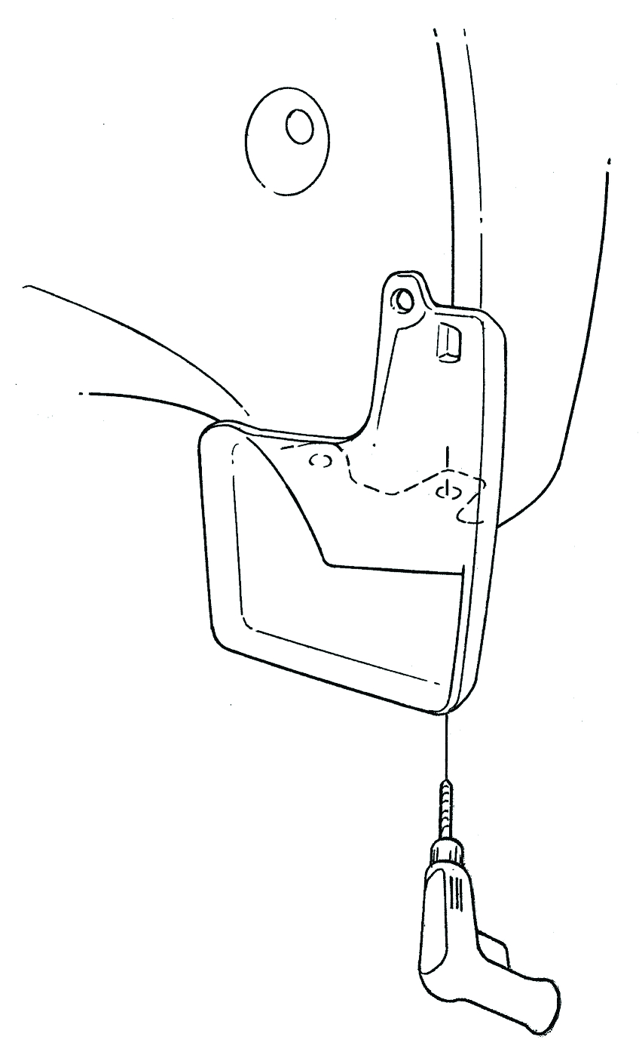
  - Temporarily position the mudguard by aligning the part with the notch on the bumper flange, and then slide it up (Fig. 1-1).
Fig. 1-1
Drill & 6mm drill bit
6mm drill bit
A
D
Notch hook
Mudguard
Drill
  - Hold the part up and into the body panel.
  - Use the part as a template and drill a 6mm (1/4”) hole through both the bumper cover & liner at location D (Fig. 1-1).
  - Remove the mudguard.

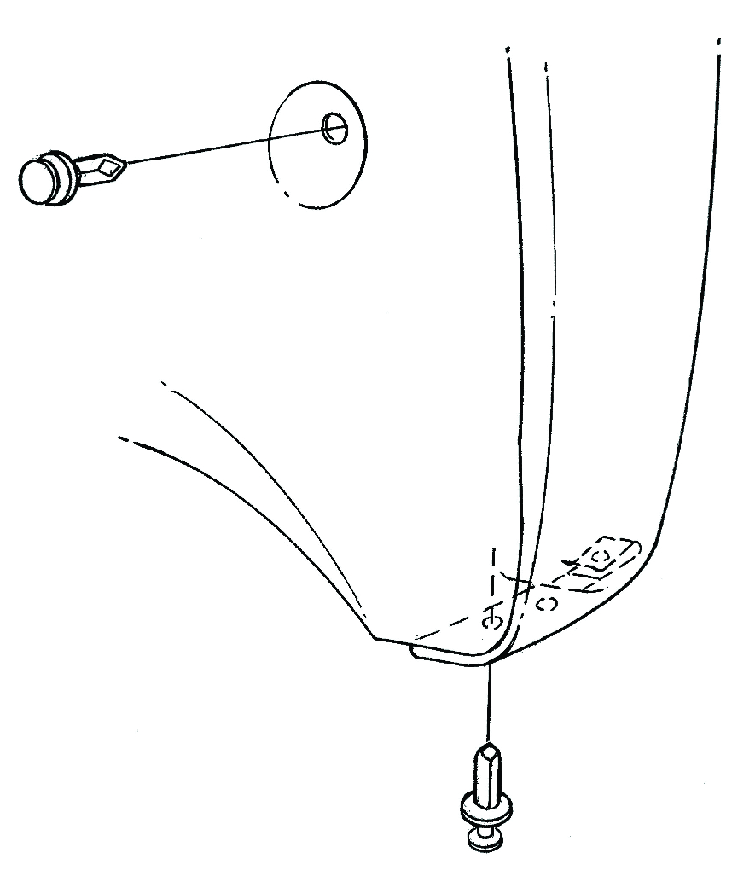
  - Remove the existing push pins at locations A and C. DO NOT DISCARD THEM (Fig. 1-2).
Fig. 1-2
Slot screwdriver
A
Existing push pin

D
C
Existing push pin
Supplied spring clip

  - Pull the liner out slightly and install a supplied spring clip with the turned up edge on the inside of liner (Fig. 1-2). Do not install the clip on the bumper edge.
  - Reposition the liner and reinstall the existing push pins in locations A and C (Fig 1-2).

Install the Mudguards.
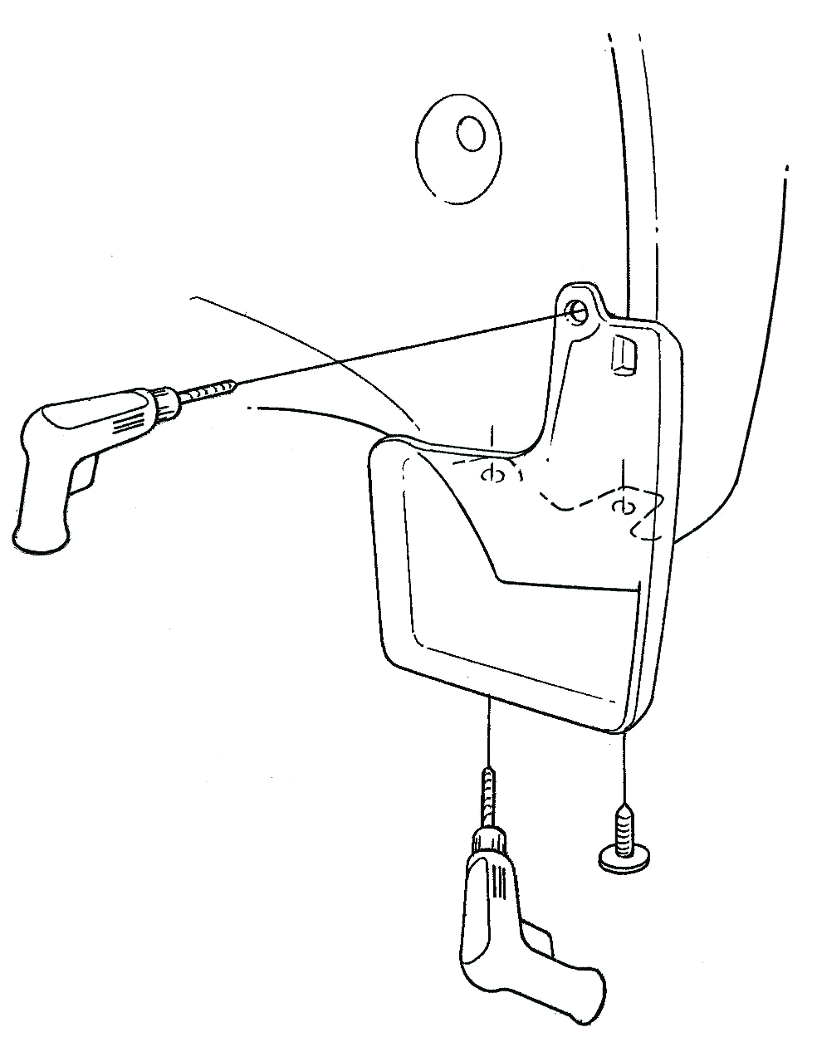
  - Temporarily position the mudguard by aligning the part with the notch on the bumper flange, and then slide it up (Fig. 2-1).
Fig. 2-1
#2 Phillips screwdriver, drill, 8mm drill bit
Notch hook
Mudguard
B
D
Supplied screw
E
8mm drill bit
Drill
Drill
8mm drill bit
  - Hold the part up and into the bumper and install a supplied screw in location D (Fig. 2-1).
  - Hold the part up and into bumper to use it as a template. Drill 8mm holes in locations B and E (Fig. 2-1).

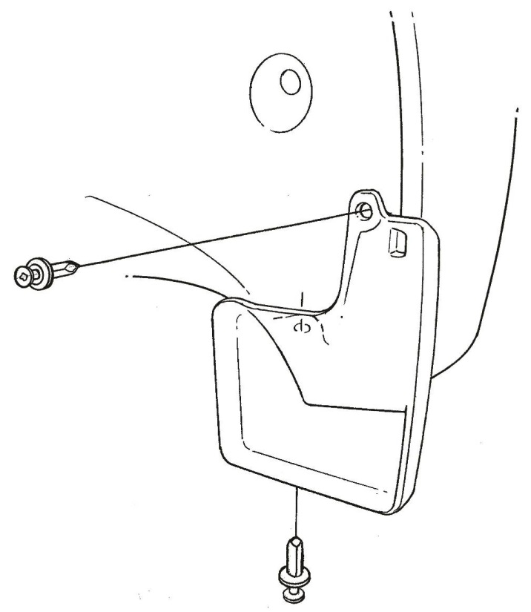
  - Install supplied push pins in locations B and E (Fig. 2-2).
Fig. 2-2
B
Supplied push pin
E
Supplied push pin
  - Repeat the entire procedure on the other side.

Accessory Function Checks
Gap between the mudguard and the body

Vehicle Function Checks

Excessive gaps greater than 1.0 mm

Vehicle Appearance Check
After accessory installation and removal of protective cover(s), perform a visual inspection.

Ensure no damage (including scuffs and scratches) was caused during the installation process.
(For PPO installations, refer to TMS Accessory Quality Shipping Standard.)

